Strathcona BIA Micro-Industrial Composting Facility

Organic waste is collected from participating businesses within the Strathcona business district and brought to the Resource Park at 1245 E Hastings. On-site composting consists of four Jora 400JK in-vessel aerated compost units. The Resource Park Site Coordinator sorts by hand the organic waste delivered to our site, selecting clean produce and removing contaminants. While Joras are able to process meat and protein waste, we choose not to use these kinds of organic waste because they take a lot of time to compost fully, and to protect against pests who are attracted to proteins. The sorted organics are then passed through a Bokashicycle pulverizer. After being pulverized, the food waste is placed in a Jora with wood pellets which are the recommended carbon source for use in the Joras. One Jora drum contains two compartments that can be filled sequentially, or simultaneously. We fill simultaneously because we have multiple Joras.
Adding between 4 and 8kg of organics per day in to each compartment of a Jora, the drum takes about three weeks to fill. As the food waste begins to break down, we monitor the temperature until the compost has achieved at least three days above 55°C. The compost then takes approximately five weeks to reach full maturity, at which point it is considered Class A compost, appropriate for all landscaping and garden applications. Normally, compost is left to mature in our Joras for up to twelve weeks. In total, one Jora cycle will process 70-80kgs of food waste. Currently the compost is given away to participating businesses of the recycling and compost program, gifted to friends of the SBIA, used in the Resource Park urban garden, and used in one street beautification project, the Hastings Urban Tree Nursery.
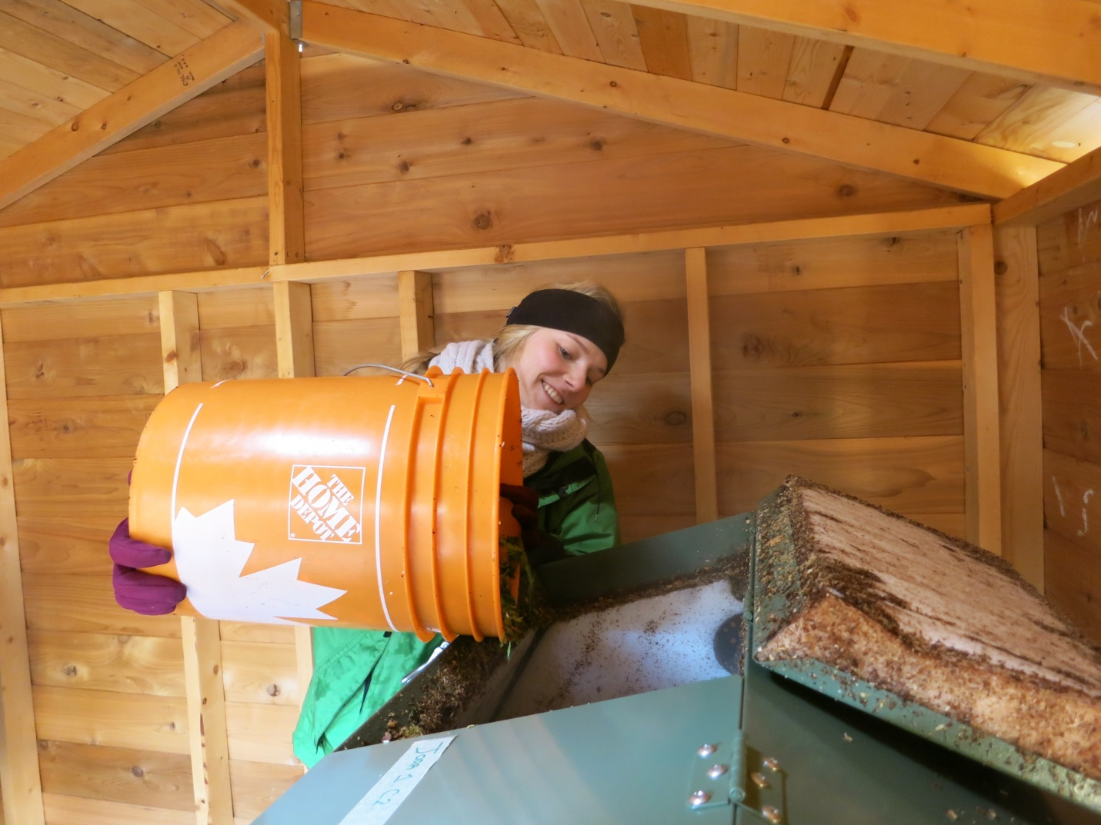
Adding food waste to a Jora 400JK
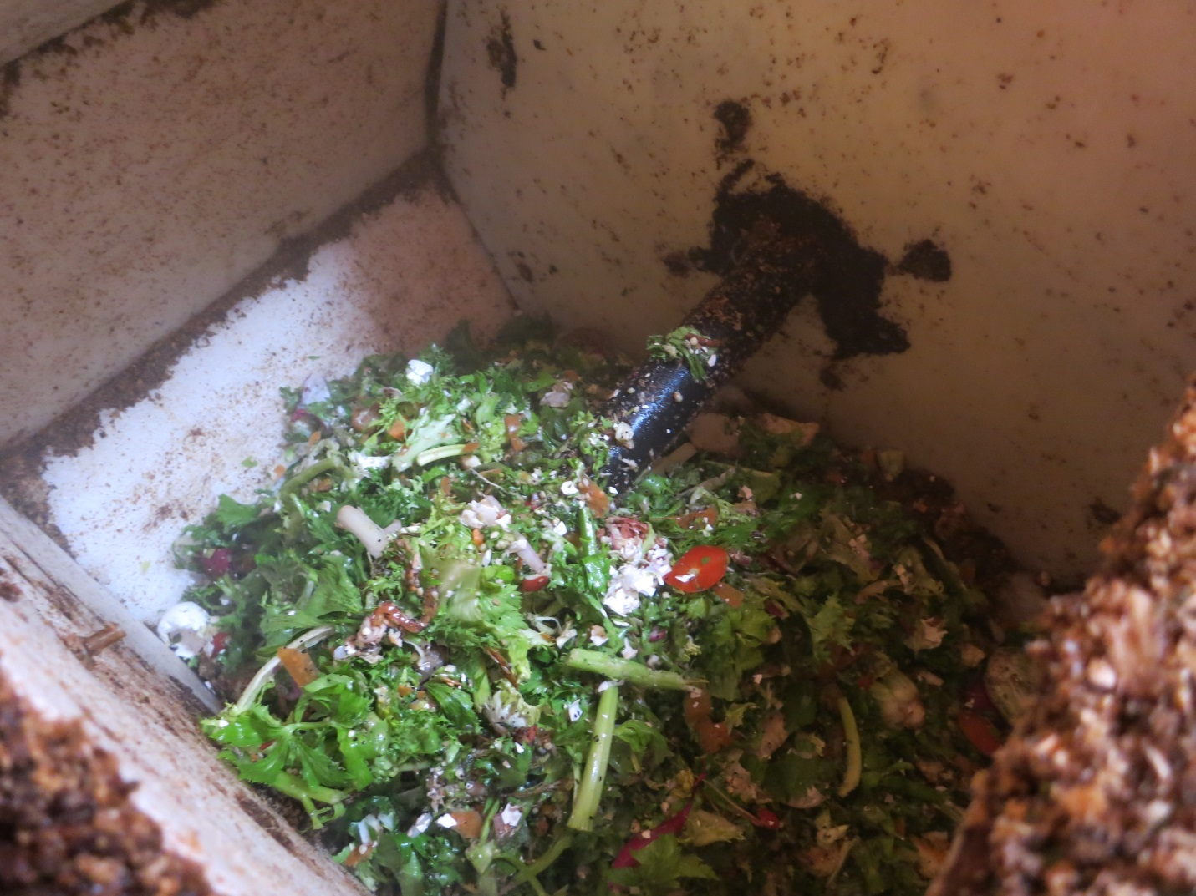
Fresh food waste in a Jora 400JK compartment
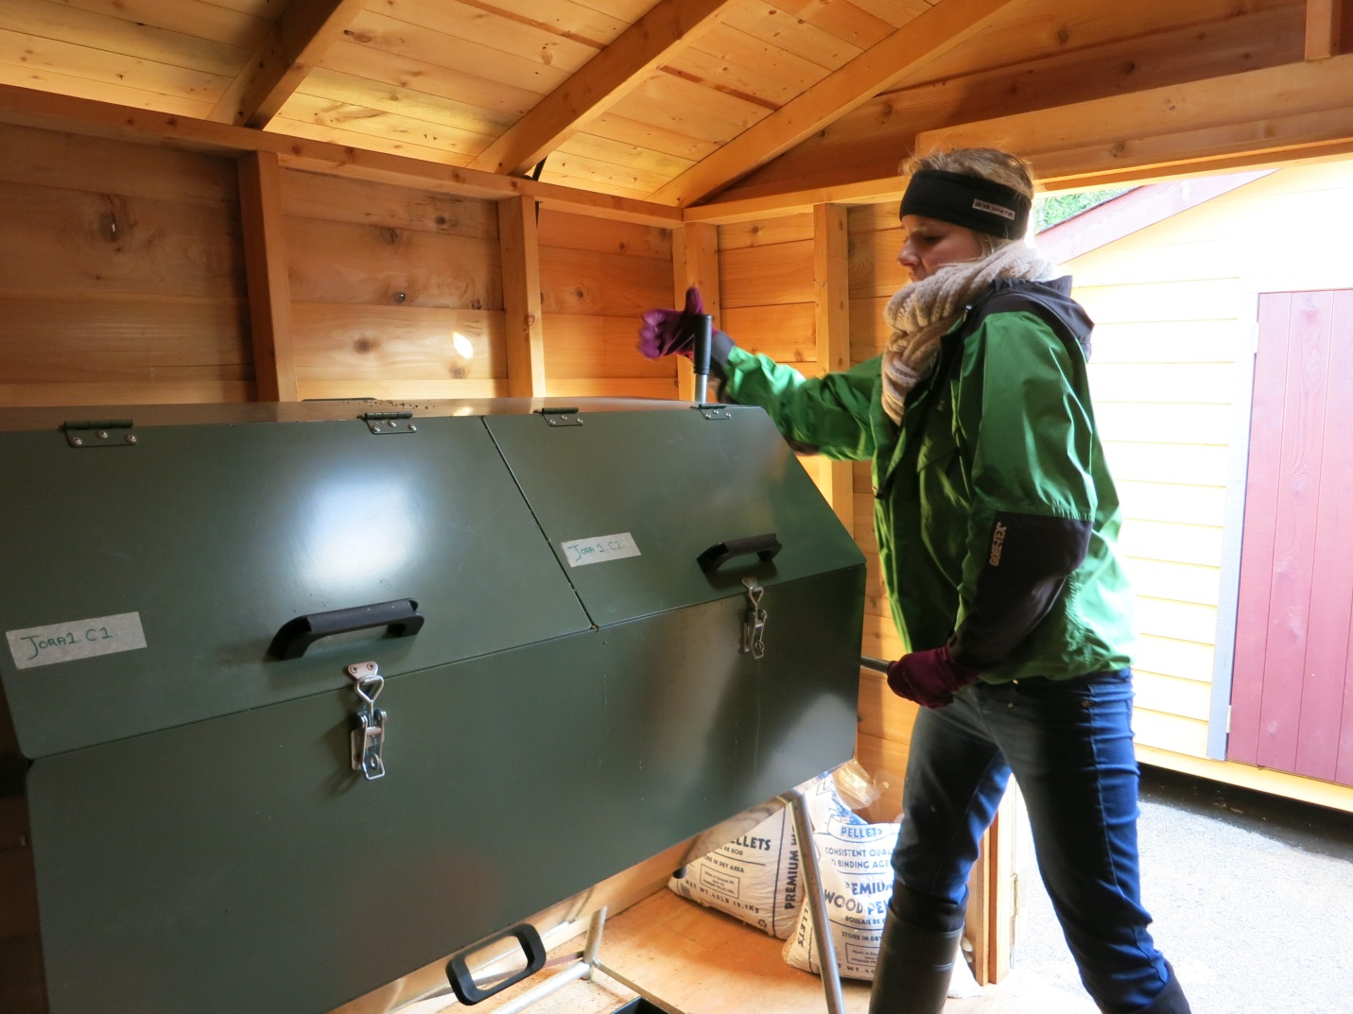
Manually turning the Jora 400JK
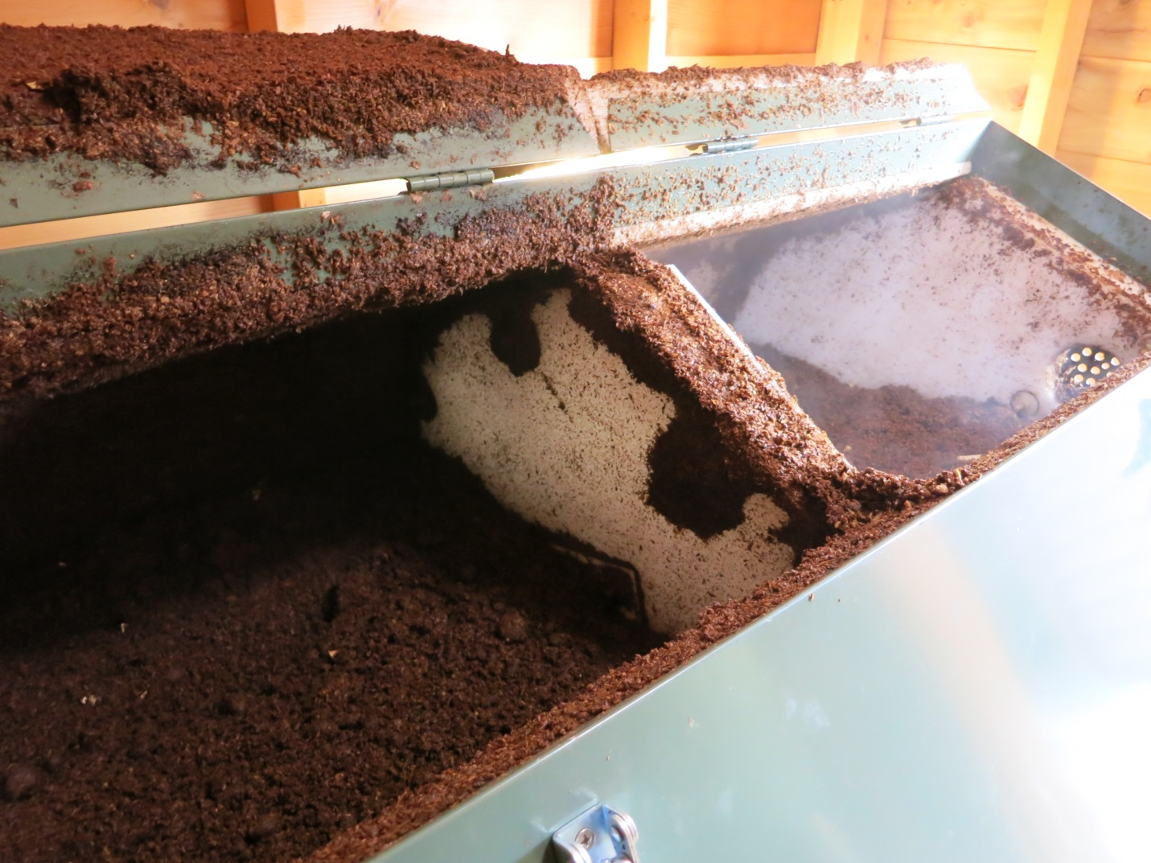
Maturing compost steaming away in a Jora 400JK
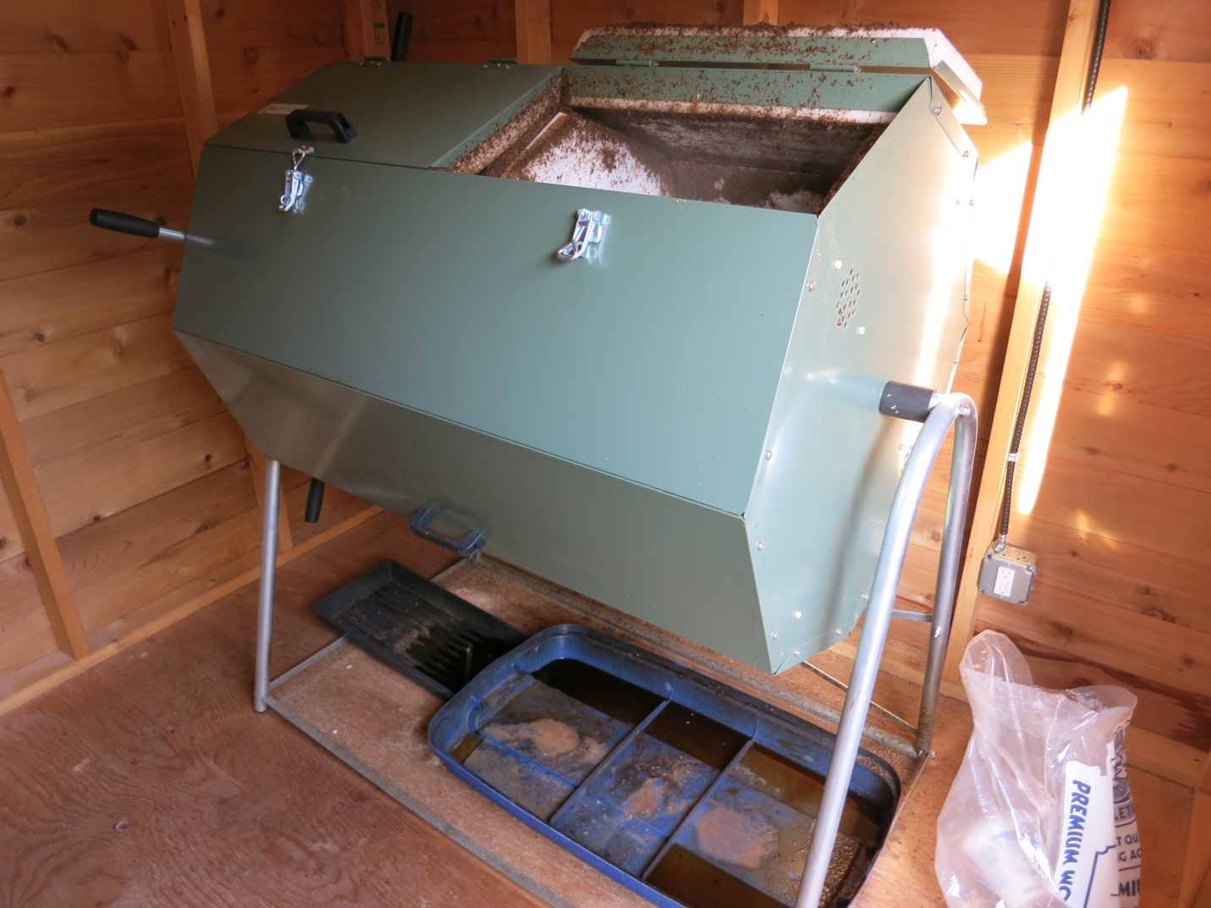
A Jora 400JK in-vessel aerated composting system, with trays to catch leachate below

