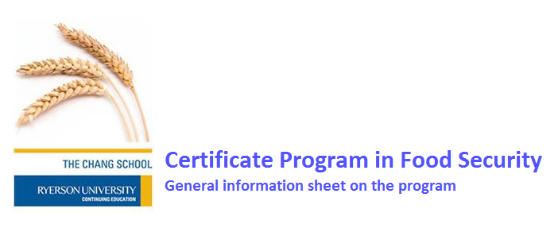

Exploring how to create economically and ecologically sustainable food systems that are socially-just and based on democratic decision making
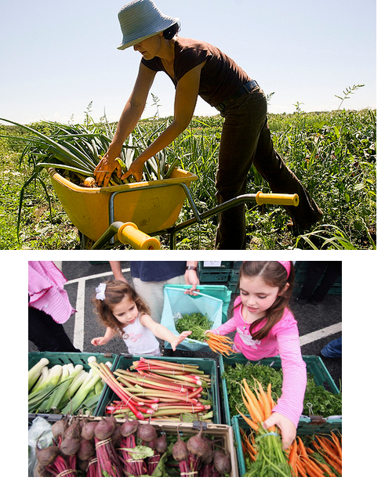

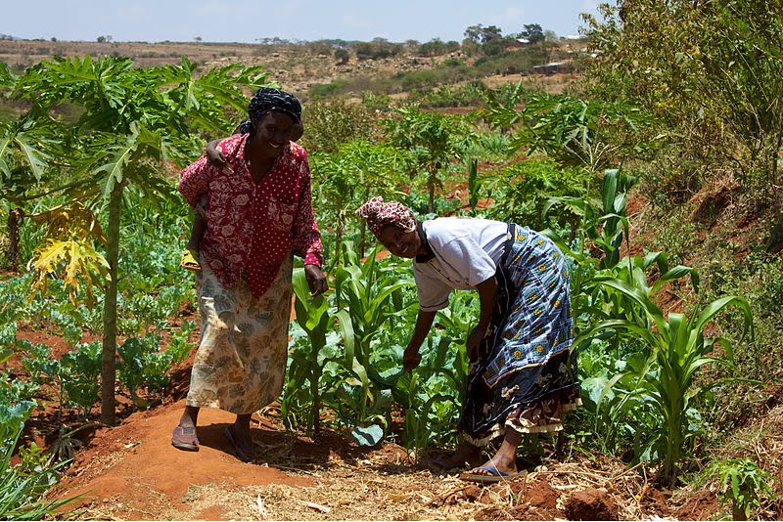

“To solve the food crisis we need to fix the food system. This entails re-regulating the market, reducing the oligopolistic power of the agri-foods corporations, and building agro-ecologically resilient family agriculture. We need to make food affordable by turning the food system into an engine for local economic development in both rural and urban areas. These tasks are not mutually exclusive—we don’t have to wait to fix the food system before making food affordable, marketing fair, or farming viable. In fact, the three need to work in concert, complementing each other.” Eric Holt-Giménez, Executive Director of Food First
Holt-Giménez, Executive Director of Food First
-Eric Holt-Giménez, Executive Director of Food First



Program and Registration Information

The Certificate Program focuses on how to meet the challenge of creating sustainable food systems based on social justice and democratic decision-making that will ensure people’s right to food. As such, the program serves anyone with a keen passion and interest in food issues, environmental sustainability, human rights, alleviation of food insecurity, food-related health and education issues, and policy development on food and food systems. Our students go on to work in civil society organizations and public sector agencies in Canada and worldwide addressing food issues and also engage in the private sector to initiate its transformation to a more equitable and sustainable system of food production, processing, and marketing.

Our objective is not to train food security experts but to provide program participants with a suite of skills and knowledge concerning food security to add to their current skill set. Whether your interest is to work in community development, education, health, social service, the private sector, farming, urban agriculture, or international development, knowledge of food security issues is very important. Activities in any of these sectors affect our food systems either directly or indirectly and subsequently people’s access to food. Therefore, it is very important for everyone to be aware of how the policies they develop and activities they undertake will influence food security within their community and beyond - See short video on the program.

About the Certificate program and available courses
Our online courses run with special dedicated software accessible with a student ID number and password. You can register for individual courses without registering for the certificate but to gain a certificate; you need to complete three core courses and three electives with a cumulative grade average of 2.00 or higher. To allow for maximum flexibility in crediting external courses and/or courses taken previously at Ryerson, students should register in the certificate at the beginning of their first course. If you do decide to do courses before registering for the certificate and then want to register, you must enroll in the certificate before completing your 3rd course otherwise the courses you have taken will not count towards the certificate.

Required Courses for the certificate (Core courses)
CFNY 403: Principles and Concepts in Food Security (Foundation course)
CFNY 404: Food Policy and Programs for Food Security (prerequisite CFNY403)
CFNY 405: Applied Research Methods and Evaluation (prerequisite CFNY403)
___________________________________________________________________
Elective Courses (Select any three to combine with core courses to gain a certificate)
CFNY 400: Selected Topics in Food Security or Independent supervised study (prerequisite CFNY403)
CFNY406: Economics of Food Security
CFNY 407: Community Development and Food Security (prerequisite CFNY403)
CFNY 408: Urban Food Security (prerequisite CFNY403)
CFNY 409: Gender and Food Security (no prerequisite required)
CVFN 410: Understanding Urban Agriculture (no prerequisite required) Urban Agriculture Course Series
CVFN 411: Dimensions of Urban Agriculture (no perquisite required) Urban Agriculture Course Series
CVFN 412: Urban Agriculture Types (no perquisite required) Urban Agriculture Course Series
CVFN 413: Urban Agriculture Policy-Making (no perquisite required) Urban Agriculture Course Series
Spring-Summer 2013 courses (Session is from May 4 – July 27, 2013)
Course Code | Course Title | Course Type | Other information
CFNY 403 | Introduction to Food Security | Core | Foundation course  Degree credit; RN
CFNY 404 | Food Policy and Programs for Food Security | Core | Pre-requisite CFNY403; Degree Credit; IK
CFNY 407 | Community Development and Food Security | Elective | Pre-requisite CFNY403; Degree Credit; RN
CFNY 408 | Urban Food Security | Elective | Pre-requisite CFNY403; Degree Credit; LB, JN
CVFN 413 | Urban Agriculture Policy-Making | Elective | No pre-requisite; Certificate credit; Urban Ag. Course Series; MD, WM
CFNY409 | Gender and Food Security | Elective | No pre-requisite, Degree Credit AM  In-class course at Ryerson for students who are based in or close to Toronto

Instructors code: RN = Reg Noble (Ryerson University); IK = Irena Knezevic (Participatory Action Research and Training Centre on Food Security at Mount Saint Vincent University); LB = Lauren Baker (Coordinator of the Toronto Food Policy Council); JN = Joe Nasr (Ryerson University); MD = Marielle Dubbeling (Director of the Resources Centre for Urban Agriculture & Food Security (RUAF) in The Netherlands); WM = Wendy Mendes (School of Community and Regional Planning at the University of British Columbia), AM = Andrea Moraes (Ryerson University) – Instructor information on Chang school website

Note: The core course CFNY404 and the electives, CFNY407 and CFNY408 cannot be done without having completed the foundation course CFNY403 or by getting special permission from the academic coordinator. However, CFNY407 or CFNY408 can be done with CFNY403 in the same session.

Click on course codes to get to the course’s web page and a short description of the courses and TUITION FEES

Urban Agriculture Course Series

The Raymond Chang School of Continuing Education is offering an online course series in urban agriculture within the Certificate Program in Food Security. The series consists of four courses and students who complete them will receive official documentary acknowledgement from the university of having achieved completion
.
The four courses CVFN410, 411, 412, and 413 provide students with a comprehensive picture of current practices in urban agriculture and the environmental, socio-economic and political challenges that must be addressed. Therefore, students who complete the course series will not only have gained in-depth knowledge of the technical aspects of urban agriculture but also of the policy dimensions and governance issues that must be taken into account for development of effective urban agriculture systems. The thematic focus of the course series is to demonstrate the importance and value of urban agriculture (UA) as an integral part of planning and development for sustainable, food-secure and healthy urban environments.

The four courses are also electives within the certificate program and can count towards completion of the certificate in food security should students wish to add a certificate to their award of completing a course series in urban agriculture. Click on course titles on this sheet for a short description of the course and fees. Course outlines are available when you click on the course titles on the UA web page. Please note: It is possible to substitute one of the urban agriculture courses with an independent research study in urban agriculture that is equivalent to a whole course. For this option, contact the academic coordinator

The courses have been developed in a unique international partnership between The Chang School and the Resources Centre on Urban Agriculture and Food Security (RUAF) in the Netherlands, which is a global leader in urban agriculture research and development. The instructors for the courses are based in Canada, Lebanon, the Netherlands and UK and bring a wide range of local and international knowledge and experience to the courses.

Criteria for entry to the certificate program

Applicants should have an undergraduate degree in any field, or approval of the academic coordinator and five years of professional experience in a field relevant to food security work, or approval of the academic coordinator and three years’ Baccalaureate study with a clear academic standing (at least a C average or GPA of 2.00) is required. Please contact the academic coordinator, Reg Noble if you have any concerns over your eligibility for the program.

How to apply for an individual course

Before registering for a course, you should go to the Chang School web pages for the Food Security Program to see the course listings and information on the program, as well as guidelines for participating in distance education. Information can also be found on the Food Security web page.

In order to apply for an individual course, check the enrollment information at the Chang School website. Check online enrollment, if you do not qualify; go to the “Forms and Documents” page, then download an application form and FAX it to distance education at (+1)-416-979-5196.
DO NOT MAIL THE FORM.

Alternatively, you can scan the application form and send it by email to distance@ryerson.ca. You can apply to join a course any time prior to it starting. In the calendar, there is a cut-off date for mail-in applications but not for faxed applications or scanned applications sent as email attachments. Ignore the mail-in deadline.

Certificate registration

For certificate registration, you must send the academic coordinator, Reg Noble a resume first in order to get approval for registration. Then, you can download a certificate enrollment form and follow the instructions for registering. DO NOT try to register without approval.
Please note the deadline date for Certificate registration is March 29, 2013

Online certificate registration – please note that if you obtain a student number, you can register online for the certificate. You need approval from the academic coordinator first. Once approved, you receive by email a code number to enter the Ryerson RAMSS system and register.

Summary of options for Certificate registration:

- Option 1: Register in the certificate prior to enrolling in the first course taken in the certificate

This option provides maximum flexibility in crediting external courses and courses previously taken at Ryerson, prior to enrolling in the certificate. Choosing this option ensures that all courses taken towards the certificate will be included in your cumulative GPA.

- Option 2: Register in the certificate prior to the completion of 50 percent of the certificate program requirements

This option allows students to attempt courses in the certificate program prior to deciding to register in and pursue the certificate. Choosing this option means that courses completed prior to registration, up to a maximum of 50 percent, will be used towards the certificate's graduation requirements, however, will not be included in your cumulative GPA.

Additional Notes about courses

- Students are expected to devote a minimum of three hours per week to a course, & sometimes more. If you are working full time, we do not recommend doing more than one course.
- Most courses have at least two to three written assignments and an exam. One assignment will be a major research paper
- Often course activities will require you going out into your community to explore food issues
- Every course requires participation in discussions and a proportion of the course grade depends on your participation. Usually the weighting for participation is between 15 and 25% depending on the course
- Many courses include real-time discussions – usually three or more per course
- Students can take up to three courses per session although this will be a heavy workload – one or two courses are the norm.
- It usually takes students between 12 and 18 months to finish the program depending on how many courses they take each session.
- The program explores food security issues locally and internationally because we are dealing with a global food system that affects food security at a local level.

Careers in Food Security

Our students find positions mainly in government and the nonprofit sector. For example, we have students who are working in the health, education, and social services sectors of the Canadian government at all levels from municipal to federal. In the nonprofit sector, students have employment with local NGOs such as FoodShare, Toronto; The Stop, Toronto; Local Food Plus; Food Secure Canada; etc. and international NGOs such the International Development Research Centre, Ottawa; OXFAM, Canada; Resource Efficient Agriculture Canada (REAP); War Child; Canadian International Development Agency and others. At the same time, many former students join local community-based organizations working in urban agriculture and enhancement of local food systems.

In this regard, a number of students have begun their own food organizations and food initiatives and use our program as a means to consolidate their ideas about how they want to address local food security. A good example of this is the foundation of the first accredited food hub in Canada, i.e. the “Kaslo Food Security Project” set up by Aimee Watson, one of our current students.

Other students have used our program to develop international development efforts. An excellent example is one of our graduate students, Catherine Robar of Halifax. She set up an NGO, the Themba Development Project which is assisting two poor communities in South Africa, one urban and one rural, to address food insecurity and poverty. Catherine won the Ryerson Gold Medal in 2011 for outstanding academic achievement on the program and for her significant contribution to community. Catherine was chosen from three food security students nominated for the Gold Medal in 2011 year. This reflects the high quality of our students.

Please note that the Certificate Program is not designed to produce food security experts but adds an in-depth knowledge of food security to the suite of skills that students already have. The objective is to not only widen the scope of employment opportunities for students but also to ensure that in whatever sector they work; they will bring their practical and theoretical knowledge of food security to bear in their policy decisions. This is because food connects to everything and all of our actions have an impact on our food systems for good or ill. Therefore to achieve sustainable food security, we need to rebuild food literacy so people can make informed decisions about policies that directly or indirectly affect our food system.
____________________________________________________________________________________________________________

Fees

Course fees are listed on the webpage for the course when you click on the course code of the course you are interested in (e.g. CFNY 403). For Canadian citizens irrespective of where they live in the world, the fee listed for a course is what you pay in Canadian dollars. However, non-Canadians wishing to apply for courses other than those in urban agriculture will be designated an international student and will have to pay international fees which are 2.5 x the fee that is paid by Canadian citizen for the course. The exception to this rule is for the Urban Agriculture courses. Non-Canadians wishing to do urban agriculture courses pay the same fee as Canadians. To clarify your status as regards level of payment for courses other than the urban agriculture courses contact distance education. Check the Chang School website for general information on fee payments and enrollment.

How to pay fees

If you are not able to come to Ryerson University to pay directly for courses, you can pay via mail, credit card, online banking, or use a payment transfer specialist.

Payment Methods:

- In person with cash, debit, international bank draft, money order, or certified cheque

- By mail with an international bank draft, money order, or certified cheque (no post-dated cheques)
Include your student ID with all correspondence
Send payment to: Ryerson University, Student Fees Office, POD64, Toronto, Ontario, Canada M5B 2k3
- Sign up with your bank for online or telephone banking
Bank of Montreal |  | President's Choice Bank
Desjardins Bank |  | Royal Bank
CIBC |  | Scotia bank
HSBC |  | TD/Canada Trust
National Bank
Add Ryerson as a payee - Ryerson University - Tuition & Res Fees
Your 9 digit student number is your account number.
Know your deadlines to avoid late payment charges.
Please allow 3 business days for your payment to be applied to your Ryerson Tuition Fee Account.
- Travelex global payment services

Questions about registration
For any further queries about registration and fee payment, please contact the Chang School at 416.979.5315 or distance@ryerson.ca.

PLEASE NOTE THAT YOU SHOULD REGISTER AS EARLY AS POSSIBLE OTHERWISE DELAYS CAN OCCUR WHICH PREVENT ENTRY INTO THE COURSE WHEN IT STARTS IN MAY 2013.

Check on the next page for links to our Twitter and Facebook pages


Check out our Facebook and Twitter accounts for new, views, and discussion about current topics in Food Security and join the debate on transforming our food system



