FAMILY BUSINESS GARDENS (FBG) IN URBAN AGRICULTURE: A 7-YEAR RECOGNISION FROM LOWER TO UPPER QUARTILES OF URBAN SECTOR IN SRI LANKA

Dr. Thilak T. Ranasinghe, Director of Agriculture (Western Province),

P.O. Box 1561, Colombo, Sri Lanka.

thithura@sltnet.lk

INTRODUCTION
In Sri Lanka, according to the resent studies, it is stated that urban population will increase from 4, 430,000 in 2000 to 9,090,000 by the year 2025. The increasing trends in greater urbanization, an ageing population and increasing female workforce in developing countries pave ways for new form of demand structures in ready-to-eat foods, functional foods (less fat, less cholesterol, less energy and vitamins added), organic products and time saving products in housekeeping. In other wards, increasing urbanization accelerates the process of switching form commodity to diverse banded consumption patterns. Thus, sustainable and economically viable resource utilization will become key aspects in promoting entrepreneurship skills in the urban agricultural production process.

In the sphere of development, pro-urban view justifies urbanization as a progressive process. According to this view, cities and towns are national and international centers of scientific knowledge and artistic achievement and also seen as agents of innovation and socio-economic transformation (Hundsalz, 2001). On the contrary, urban agriculture has had resurgence in the past 20 to 30 years and is in diverse societies being considered either useful or not attractive according to conventional rural and urban practices, some of which are no longer pertinent. The ethics of rural agriculture is not always appropriate to all aspects of urban agriculture. The existing ethics in urban development and management is more often in conflict with urban agriculture due to the profit maximization goals of urban administration. However, ethics of urban agriculture will surely be a unique mix of moral verities and operational principles (Smit, 2007). It is aligned with the “cleaner production concept” that advocates reducing the risk to humans and environment and, increasing overall efficiency of products, processes and services.
Within this premises the concept was practically launched on the World Environment Day of the year 2000 on a demonstration basis at the suburban town of Mathugama, Sri Lanka by the Western Province, Department of Agriculture (WPDOA). The main argument of the concept of the FBG is to show the necessity of converting the simple form of home gardening into a source of family nutrition supply and mental satisfaction that is based on the sustainable entrepreneurship. In this context, the concept of the FBG believes that there should be proper mix of environmental improvement aspects and commercial agricultural interests in the process of sustainable homestead development (Ranasinghe, 2003).
DISCUSSION
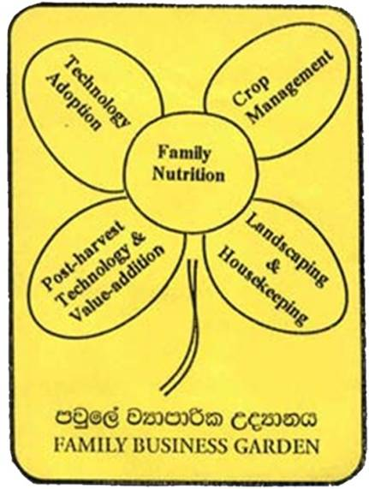
Urban agriculture is defined as an industry located within (intra-urban) or on the fringe (peri-urban) of a town, a city or a metropolis, which grows and raises, processes, and distributes a diversity of food and nonfood products, using or reusing largely human and natural resources, products, and services found in and around that urban area, and in turn supplying human and material resources, products, and services largely to that urban area (Mougeot, 1999). In this context the concept of the FBG sits on four major aims in reaching its target groups in the process of urban development. Those are: to convert the aspect of gardening into a theoretically based sustainable agri-business concept, to address some poverty issues in generating additional income for food security, to work with better mix of modern science and indigenous technical know-how (ITK) and to make contributions for attempts of improving socio-economic-health-environment aspects of urban communities.
Figure 1:- Logo of the Concept of the Family Business Garden
In studying the epistemology of the concept of the FBG one can recognize five main components in relation to human-economic-ecological-technical premises with specific reference to the urban context. The logo of the concept shows these five strategic components of its different shaped and sized petals: i.e., family nutrition, technology adoption, crop management, post-harvest technology & value-addition, and landscaping & housekeeping (Figure 1). The centre petal is the prime need of the family as basic requirement of development. The dual-stalk symbolizes the ability of approaching the concept either commercial or environment basis or combination of both for sustainability. All in all, the brand of FBG depicts the flexibility in adopting five strategic components in entering into the concept as per different socio-economic-cultural-environment conditions of urban families. Those components are discussed as follows.
Components of the FBG
i) Family nutrition: first and foremost, food safety and balanced meal is highly stressed for better nutrition supply. In attaining this goal one should allocate some space to cultivate few favorite-nutritious vegetables, fruits, yams and spice crops of the selection made by family members. If they are interested animal husbandry can easily be integrated into the sustainable production process. Within this component the concept encourages locally based crops and animals that viably suit to natural and socio-economic setting. In this context, environmental friendly methods of plant protection are advocated: i.e., Integrated Pest Management, use of bio-pesticides, green & clean product development strategies. It is always stressed that use of “Low/No-space techniques” is a must in optimizing the limited space with different “Vertical Living Structures” and in turn to improve dietary habits of urban communities (Figure 2).
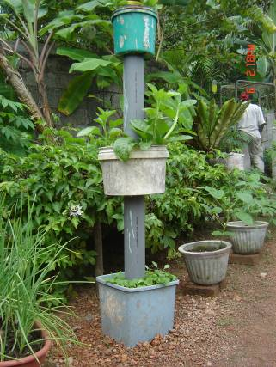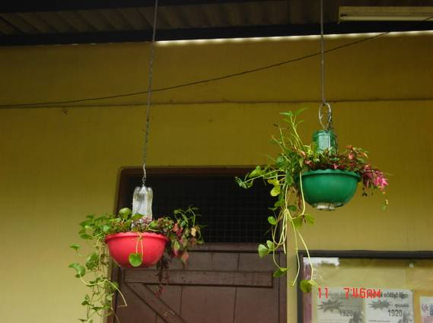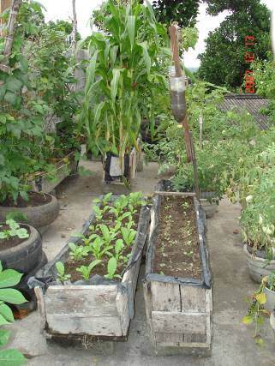
Figure 2:- New live-structure additions to the Concept of the Family Business Garden (FBG) - from left to right: Cultivation Bangle, Cultivation Lantern & Cultivation Canoe
ii) Technology adoption: it is important that wherever possible urban households should produce selected economically viable few crops or process some products for market to generate income as small or medium level entrepreneurs. For this end one should select new crops/new products rather than stick into produce family-prefer crops/products for the market for long-term sustainability of family entrepreneurships. A proper integration of ITK and modern technology comes to play a major role in this juncture. Developments of vertical living structures have been progressed according to creativity of recipients of the concept. For instance, cultivation tower, rack, bottles, tats, ladder, pyramid are some of those examples for appropriate technology developments. This component allows making diversity in technological creativity.
iii) Crop management: soil and water management (quality as well as quantity) is treated with high priority within the concept of FBG in order to manage long-term productivity. This component advocates to practice recycling techniques of plant nutrients (i.e., living frame, crop rotation, use of green/animal manure, compost making by house waste, so on), proper water utilization and management practices (soil and water conservation cultural methods, water harvesting techniques, pitcher irrigation, micro irrigation techniques, so on) wherever possible and applicable. Management of shade or sun-light too is considered as an important aspect of limited space utilization in urban agriculture. In the end the component attempts to upkeep physical fitness of urban dwellers.
iv) Post-harvest technology and value-addition: even though products come from homesteads the quality of products has to be met with marketable standards in order to compete with multinational products available at local markets. Because consumers, even owners/managers of FBG, are only ready to purchase quality items that meet their preference and go along with their urban lifestyles. Thus, post-harvest management is a must and product diversification by producing varied value-added products to meet changing patterns of consumer behavior paves the ways to success of the concept of the FBG. It is highly stressed that as small or medium scale producers, they should organize themselves into producer groups/associations or out-grower groups to gain economic advantages while allowing diversity in agricultural products and processes.
v) Landscaping and housekeeping: as a cottage industry, the concept of the FBG tries to build the dignity of farming by providing an idiomatic and an elegant look to the own craftsmanship of his/her agricultural entrepreneurship. This component provides access to neutralize mental depression and improves capabilities on how to organize themselves as managers/manageress in dealing business and personal matters through environmental and psychological contexts. The creation of pleasant environment through the principles of edible-landscaping architecture and the guiding provisions of housekeeping/personal organizing abilities through the principle of personal psychology are the essence of this component. It is also stressed that creation of charming environment in and outside of the home/business keeps the agro-entrepreneurship more manageable as they improve their mental fitness in healthy urban life.
Impact of the FBG
The impact of case of the FBG being implemented in the Western Province, Sri Lanka is analyzed here on the aspects of livelihoods improvements, productivity and profitability influence, managerial diversity and holistic involvement in achieving urban sustainability through micro-level agricultural development initiatives.
Livelihoods Improvements: As an owner of the FBG one can not only cultivate floricultural crops but to cultivate food, medicinal, forestry and rearing livestock in improving level of biodiversity in urban areas. In creating edible land and air-scapes in homesteads one can create opportunities to improve physical fitness. It is also revealed through psychosocial research that planting medicinal herbs for fresh herbal treatments under diverse treatment techniques may reduce the level of stress towards the development of the Gross Happiness Measurements of a country. In this sense, Subashini at Katana initially cultivated about 50 plant species of herbs, vegetables, fruits and flowers in the homestead and later reduced to few crops from each category by seeing the economic value to reduce the cost of food basket while achieving satisfaction and happiness through edible landscaping.
Nutrition and health is a prime area of human sustainability. Concern on health aspects of underserved as well as well to do people in urban areas is a major focus of the FBG and also a direct impact measurement. The FBG has provided access to fresh, healthy and home-grown products and also provided physical fitness as well as mental happiness which leads to upkeep long-term wellbeing of urban communities. For instance, Adlina at Panagoda shows how far she has earned essence of mental happiness to upkeep physical fitness in the old ages. In addition, her FBG generates sustainable source of additional income through micro agro-entrepreneurship attempts. By now it further provides access to convert “fast-food eating habits” into “slow-burning eating habits” that leads to reduce non-communicable disease incidences (i.e., high sugar levels, high pressure levels, misbalanced cholesterol situation and obesity problems) among urban communities who are addicted with sedentary life style patterns.
The consumption of leafy vegetables helps to reduce incidence of malnutrition in underserved communities and hyper-nutrition problems in well to do communities. Cost reductions of family food baskets will also easily be influenced by being engaged in the concept for under employed women and unemployed youth in urban communities, especially the underserved populations in urban areas. Although in the underserved community group, Daya Nishanthi at Rawatta, Mattakkuliya provides an ideal example as she adopts different types of vertical living structures in her limited space to feed the family with few seasonal as well as perennial leafy vegetables (Figure 3).
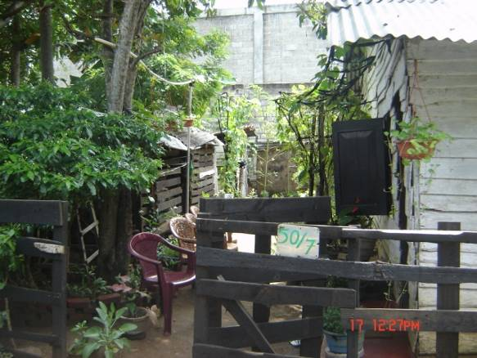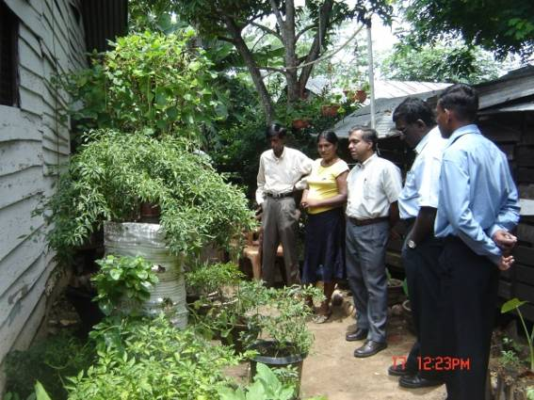
Figure 3:- An example for application of the Concept of the Family Business Garden (FBG) by the lower quartiles through urban agricultural extension programmes
The innovators of the adoption process of the concept accepted novelty nature of vertical living structures irrespective of age groups in urban communities. Swarnamali as middle-aged woman at Maradagahamula of peri-urban area began to do micro venture collection of bee-keeping for honey, production of planting materials and cut flowers for local sales while converting the homestead into an edible form of landscaping with essential food crops grown in living structures by family choice at the inception of the concept introduction. Furthermore, on the self initiative she became a paraprofessional agent of the concept in that area.
Productivity & Profitability: The concept of the FBG itself sits on the base of proper mix of scientific Knowledge and Indigenous Technical Know-how to up-keep family business in productive as well as profitable levels. In the context of better management of homestead garden to produce balanced dietary requirements with appropriate levels of Integrated Pest Management (IPM) and integrated farming (i.e., crop and animal husbandry together) is productive while making use of any excess production for value added product preparations. The use of cultivation structures at convenient standards for low/no-space cultivation methods helped to reduce pollution levels low and clean the environment while contributing direct impact to city dwellers in reducing public health costs (e.g., rooftop gardens of Perera’s family in Pamankada, Sunil’s family in Battaramulla & Jayawickarama’s family in Galawilawatta - Figure 4). Urban dust, smog, dirt and sound can be absorbed by using appropriate crops cultivated in homesteads of city limits even as micro level entrepreneurships. In future micro-level agro-enterprises could be promoted with modern scientific applications such as aeroponics, acquaponics, omega-gardens and the like.
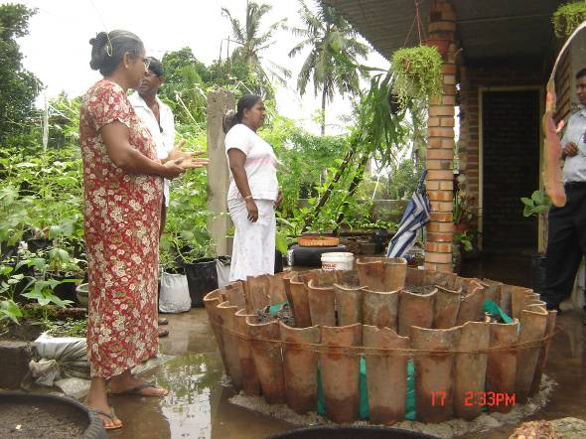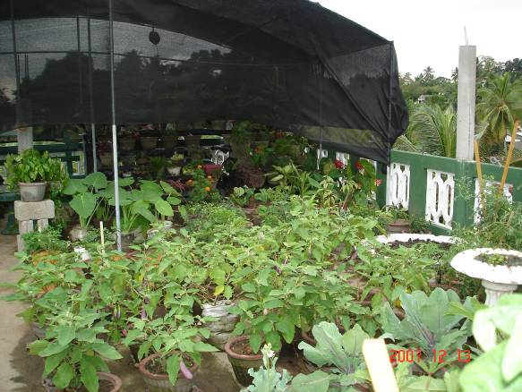
Figure 4:- Creativity of middle –level income groups is welcomed by the concept of the Family Business Garden (FBG) and newly constructed cement roof-tops are often converted into “Rooftop Gardens” in the city of Colombo and the suburbs.
Different life style changes along with changes in eating habits provide new accesses for diversified agro-entrepreneurships in urban areas for long-term income generation activities. As a result, small and medium scale enterprises could easily be benefited by integrating ITK with modern scientific research findings. For example, plant nursery management, mushroom cultivation and processed cum preserved products for value added enterprises are popular among urban dwellers according to the available members in households, available money for capital expenses and land space availability and, family preferences. For instance, as a young entrepreneur Chandana at Kadawatha extends great service in selling readymade-pod-plants and seedlings through his roadside-enterprise located in Kandy-Colombo main road.
Use of technical know-how for reuse of liquid and solid house waste and make use of unwanted space for productive and profitable ventures lead to gain direct, indirect and intermediate impact on city development. The adoption of home-compost making techniques through the methods of live-frame, pit, bin or ditch system paved different ways and means for city administrations with the assistance of civil society groups to maintain at least selected clean areas in city limits (e.g., Gampaha & Moratuwa Municipal Councils).
Managerial Diversity: The management of micro-enterprise means to add professional management skills to existing entrepreneur styles of an entrepreneur through wider reading, attendance at training courses, speaking to peers and attendance at exhibitions, seminars, etc (McKeran, 2004). In this context, wise sort of theoretical integration is essential for urban agriculture as it should be reached at the level of entrepreneurship for fruitful sustainable urban growth. This is the reason to invent the concept of the FBG in paving way to contrast urban agriculture from rural agriculture. As the concept stresses to make use of limited space one must need a selection of food crops according to the needs of family and size of the family business. Low or no space techniques have to be sorted out while quality of production and product has to be well managed from the very beginning of an agro-enterprise.
The concept beneficiaries directly gain individual income specially who admired to the post-harvest technology and value-addition component through different market explorations and product diversification strategies. Those who used to produce mushroom either fresh or dehydrated form go for supermarket as well as new market at “waiting parents outside school gates during the school hours” for added financial gains. Evon from Katana has been supported by the concept at the initial stages of food processing and preservation now links with established market and produce diverse quality products for changing demands at urban food markets. Furthermore, highly motivated woman of Iddamalgoda at Homagama cultivate mushrooms with vertical models while managing an effective out-grower programme for fresh and dehydrated mushroom products for supermarkets is another success example of the concept. Recently joined Luxman at Godigamuwa and Munasinghe in Pannipitiya manage their FBGs having cleaner production goals in increasing value addition and reducing waste and costs of production systems (Figure 5).
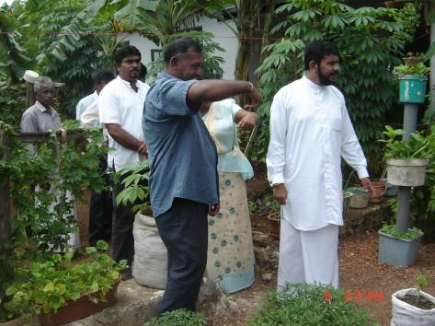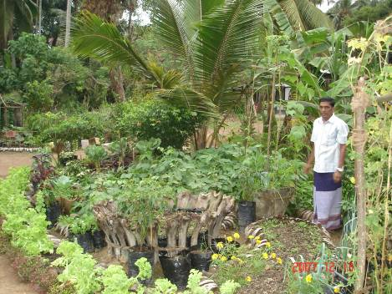
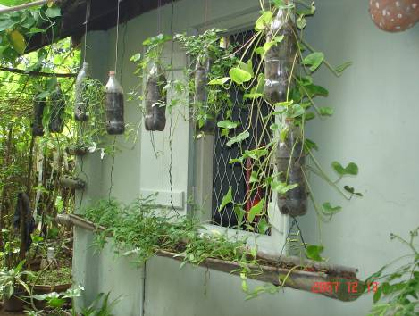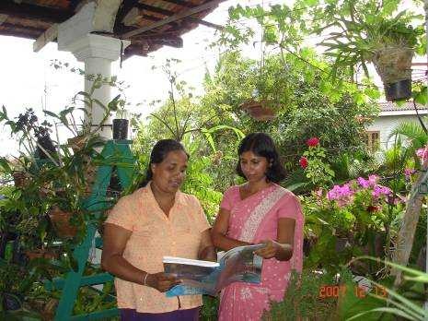
Figure 5:- Middle income families show there innovativeness in different ways and their attempts are recognized by the extension staff along with political patronage through field tour and field day programmes
Those types of experiences help to improve management systems of delivery mechanisms of service organizations like agricultural extension while providing indirect impact to municipal administrations and to profits for different service providers in urban areas. In a developing knowledge base of city dwellers service organizations can adopt different strategies in extension methodologies. For instance, recent introduction of “Extension Street Walks” by the WPDOA to meet city dwellers through team work of extension agents is one of the innovative and strategic ways to respond the changing expectations of urban communities as well as for urban economic and agricultural advancements (Ranasinghe, 2007).
Holistic Involvement: The family nutrition component of the FBG facilitates involvement of family as a group in urban agricultural initiatives and Yamuna in Maharagama educates her kids on those values. This is to educate young generations on agriculture and to relive from bad-food habits (i.e., addiction to fast foods) commonly found among upper quartiles in urban communities. In the end, she with her family experiences mental satisfaction by managing the Family Business Garden in city life (Figure 6). In addition, recycling of house waste by converting solid organic waste through composting and inorganic solid waste through different re-using processes (i.e., make use of plastic items to make simple vertical living structures) are progressed well with innovations promoted by technology adoption and crop management components of the FBG.
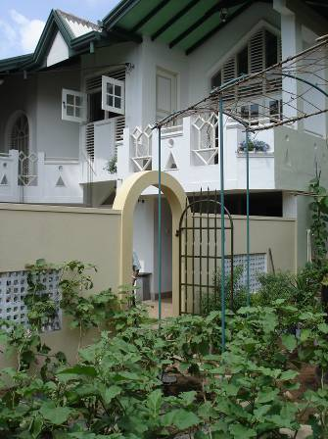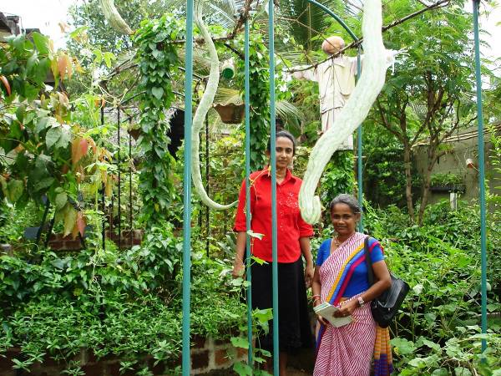
Figure 6:- Families of upper quartile of urban societies take initiatives to become involved with the Concept of the Family Business Garden (FBG) through agricultural extension advocacy of “edible-landscaping” while improving mental and physical health
Agricultural Research- Extension-Training field dialogues, exhibitions, training, workshops and field tours held in and out of the province has generated awareness and further new opportunities to expand knowledge base of urban agriculture. Moreover, political leadership helps to facilitate the process of networking of information and applications at grassroots, divisional, district, provincial and the national level. In addition, some universities recognized the concept viability in the urban development process as a new way of entrance to agro-entrepreneurship and given hands to strengthen the information networks of urban agriculture. It is identified that urban and peri-urban agriculture has high potential in economic development and university students selected do research in this field for their theses building which shows the indirect impact of the concept.
In the arena of “agriculture in schools”, the concept identifies opportunities to introduce enjoyable agriculture so as to popularize agriculture as a viable venture for youth and to introduce as a third-generation farming system namely limited space agricultural development by future farmers. The international organizations such as International Committee of the Red Cross (ICRC), Resources Centers on Urban Agriculture & Food Security (RUAF) and Food & Agriculture Organization (FAO) participated in different field tours and field days organized to reveal the potential opportunities of the concept applications and later ICRC & RUAF stepped forward to promote the concept of the FBG in the Western Province, Sri Lanka.
In achieving those attempts within the concept of FBG, the Gampaha Municipal Council has become the third city of Cities Farming for Future (CFF) Project in the South & Southeast Asia, next to Hyderabad and Bangalore cities in India, within the urban development attempts of RUAF. By now, the concept is networked with other urban development initiatives of the world through different knowledge management processes. Moreover, the Government of Sri Lanka declared “Cultivation Drive” on 3rd September, 2007 to produce locally grown crops so as to reduce food imports for the next three years. Within the drive urban agricultural initiatives are prominent due to the achievements gained in implementing the FBG work in the Western Province. It is a great impact of the FBG for the last seven years as the government not only focuses its attention to the urban private homesteads but also lands available in public and private institutions, schools, lands owned by security forces and homesteads of public representatives. As such holistic involvement is being on the progress and it is unstoppable.
KNOWEDGE MANAGEMENT & NETWORK BUILDING
Innovative urban dwellers joined the FBG initiatives by involving themselves on “Knowledge Management Process” of the concept. That is by attending seminars, trainings, demonstrations and participating adaptability testing trials conducted by extension agents. Those activities are further expanded and networked at the level of entrepreneurship with the help of civil society groups who mainly work on women in development. By seeing those moves, municipal authorities joined hand in glove with concept of FBG as a mean of development for a cleaner city by reducing the urban waste management cost, lowering the administrative cost of human health and finding new income generating opportunities of agro-tourism in city limits.
The knowledge on FBG reaches many urban dwellers in Western Sri Lanka, through a variety of communication channels: mass media methods – newspapers, magazines, posters, hand-bulletins, almanacs, stickers, hoarding at road sites, radio and television; interpersonal methods – exhibitions, seminars, action-research sessions, workshops, training classes, demonstration sites, field days and field tours; individual methods – visit to information centres, telephone calls, letters, e-mail communication, project involvements, thesis assignments, so on (Figure 7).
Figure 7:- Recent campaign attempts inpromoting the Concept of the Family Business Garden (FBG) use the above communication aids at mass-scale – from left to right: Sticker, Wall-Poster, Road-Side Hoarding & Newspaper Adverstisement
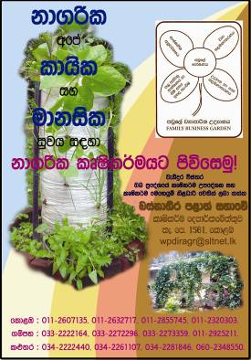
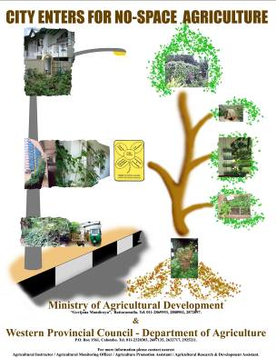

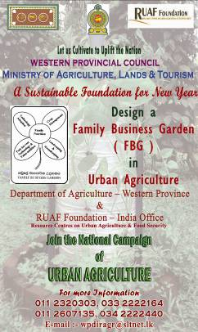

Urban exhibitions of FBG helped to open up new perceptions of urban agricultural micro entrepreneurship such as “Vertical Living Structures,” and service provisions in “Edible-Landscaping,” or a market for “ready to use compost manure”, hydroponics, micro irrigation systems, vegetable plants, etc. In addition, micro group formations which are facilitated by agricultural extension and training agents opened up access to new, and diverse forms of, value-added product ventures.
The innovative activities and initiatives of urban dwellers in the Colombo and Gampaha districts also reached the attention of policy makers, who have included urban agriculture in local and national policies. The innovative conceptual approach of FBG by the WPDO A and its agricultural extension agenda assisted in getting urban agriculture into the National Policy of Agriculture and Livestock: 2003-2010, specifically the Policy Statement No. 29 in the policy document of 2003. Also in the new Government’s Agricultural Policy of 3rd September, 2007, included a specific focus on urban agriculture (in the Statement No 17).
Interactions with other government ministries and departments (like Health, Women affairs, Education, Mass Media & Information, Religion & Cultural Affairs, Central Bank of Sri Lanka, National Science Foundation and Hospitals), NGOs (like Sevanatha, Agromart, Red Cross Society, SANASA,), private organizations (Lanka Transformers, Vagavota Agro Services, Chemical Industries Colombo-CIC) and community based organizations contributed to create links between small groups or civil society groups and with institutional networks. Also attention to FBG at schools, vocational agricultural training programmes and even at universities and post-graduate courses, assure future attention to the concept. Projects with Local Government and with International organizations like ICRC and RUAF helped to influence city planners and to convince donors in addressing urban poor through agricultural development strategies.

CONCLUSION
Through national and international linkages, promising opportunities to further develop the concept of the FBG can be observed, such as roofscape technology, tissue cultures, acquaponics, aeroponics, organoponics and the like. This together with a rising interests among the urban young entrepreneurs, and increase in demand of urban consumers to natural, healthy and nutritional food products, picture a growing market for FBG.
The concept of the FBG allows an urban dweller to have on the job learning experience, personal investment, informal systems and procedures, and to become an independent manager in the sustainable form of development (Bridge, O’Neill & Cromie, 2003). Social capital development through micro group formation and entrepreneurship will help to reduce violence and improve city life of the poor by raising living- standards.
By now, in 2008 - the International Year of Sanitation (IYS), `the concept of FBG is seen as an important and workable concept in the process of sustainable urban agricultural development.

REFERENCES
Bridge, S., O’Neill, K. & Cromie, S. (2003). Understanding Enterprise, Entrepreneurship and Small Business, 2nd Ed, (New York: Palgrave Macmillan)
Hundsalz M. (2001). Key issues for an integrated policy on integrated development. Agriculture & Rural Development. 8: 5-55
McKeran D. (2004). Planning for Growth: The Key to Development, Viva Books Private Limited, New Delhi
Mougeot L.J.A. (1999). Urban agriculture: definition, presence, potential and risks, main policy challenges. Cities Feeding People - IDRC Report 31
Ranasinghe T.T. (2003). A novel living agricultural concept in urban communities: Family Business Garden, The International Journal of Sustainable Development and World Ecology 10 (3): 239-245
Ranasinghe T.T. (2007). Potentials & Promotion of Urban Agriculture (UA): New Trend in Agriculture, The Organization Professional Associations (OPA) Forum Committee (Memo), The Professional Centre. Colombo
Smit J (2007). Ethics of urban agriculture: farming within the human settlement, Urban Agriculture Notes, http://www.cityfarmer.org/colombo.html

**************

